**// TYPE CASTING INT->DOUBLE**

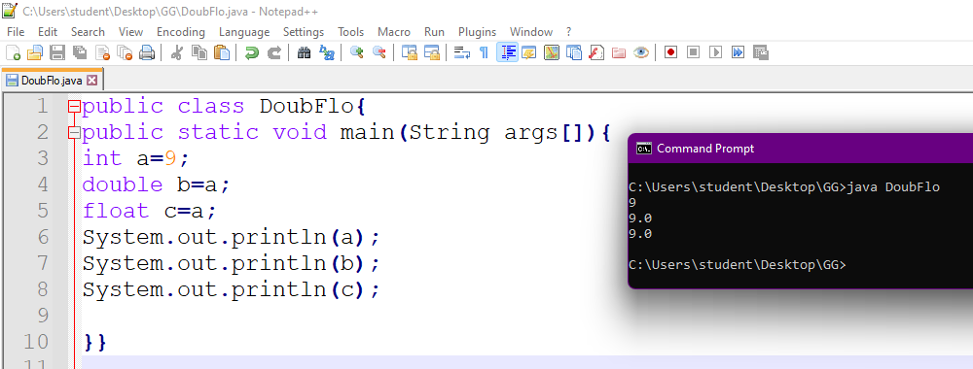

**// Type casting int -> float**

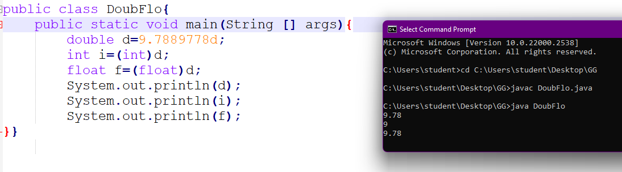

**//String + Number**

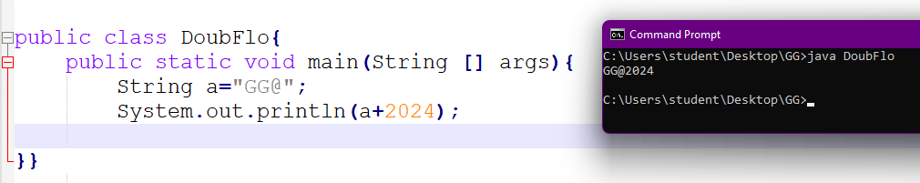

public class DoubFlo{

public static void main(String[] args){

int a=10;

double b=10.9;

int x=(int)(a+b);

System.out.println(x);

}}

//ternary operator

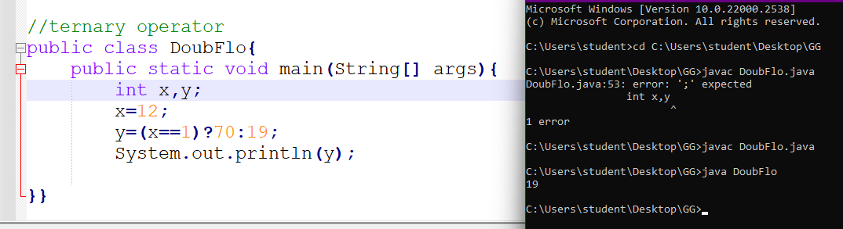

//length of the string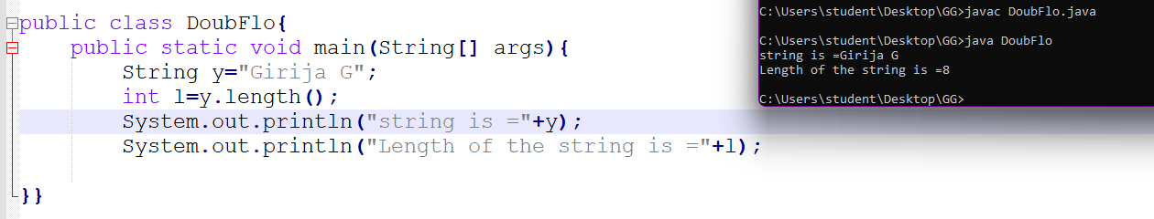

// convert to uppercase and lowercase

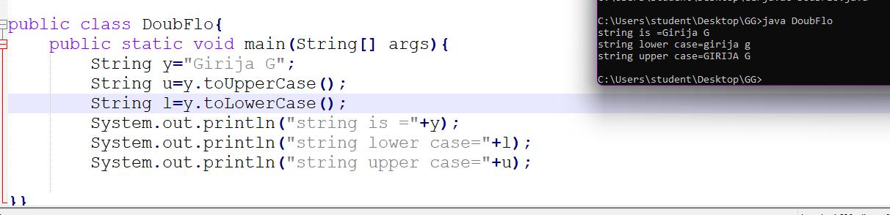

//indexOf() method

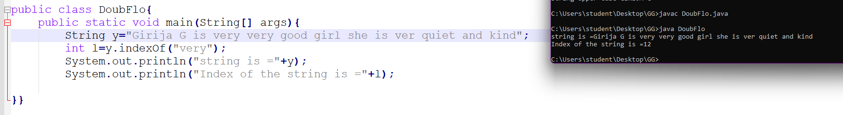

//21.07.2024

//Concatenate numbers and string

public class Main {

    public static void main(String []args)

    {

        String a="gg /nis very good\rwhat is ahppe\nning girl happy birthday everyone\t i have kindom in uk\b that good actually\f fine thankyou";

        System.out.println(a);

    }

}

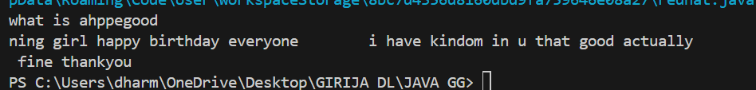

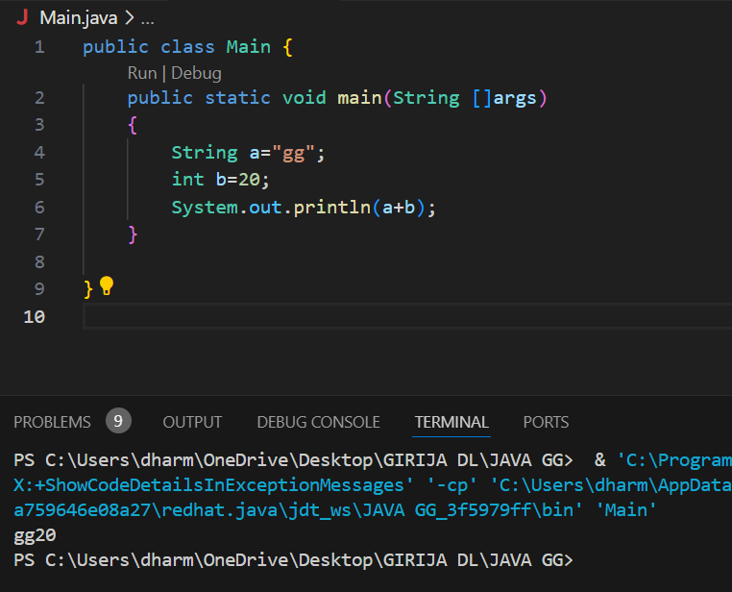

//JAVA MATH

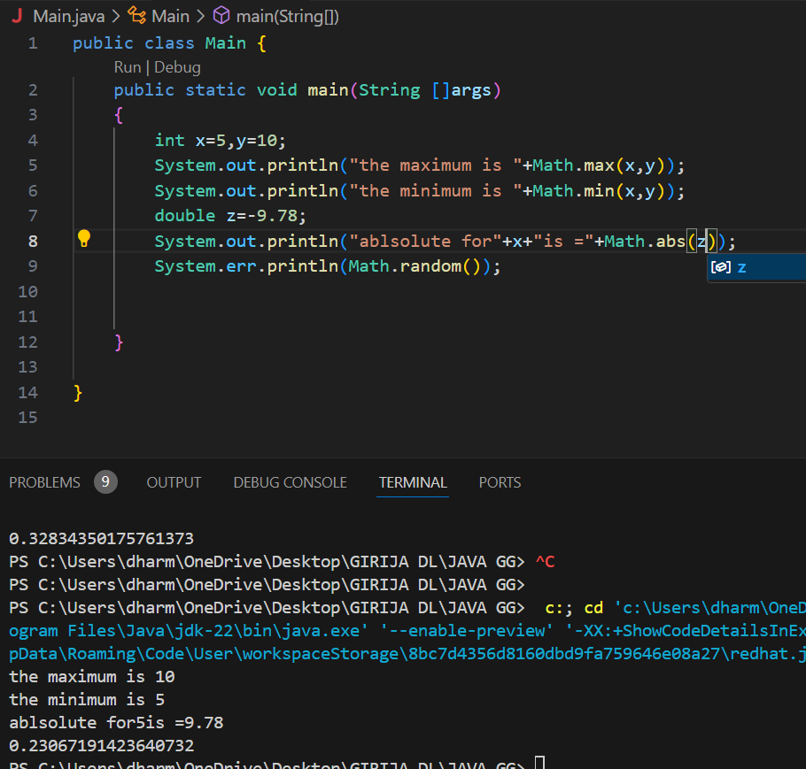

//BOOLEAN DATA TYPE

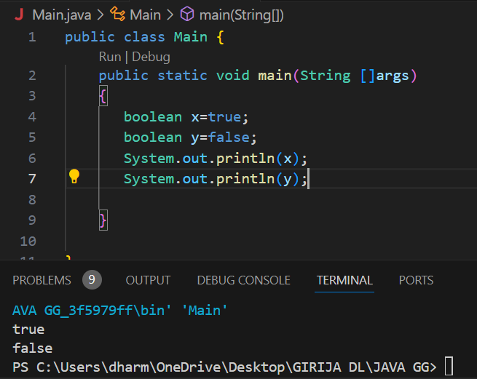

//x>y

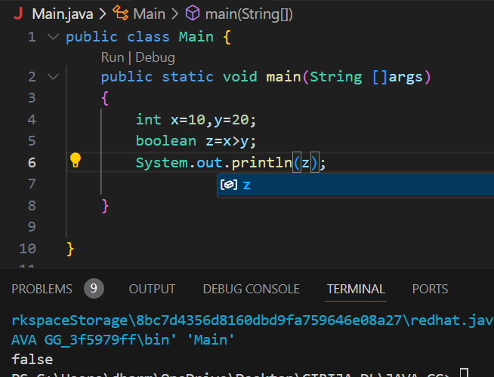

//IF statement

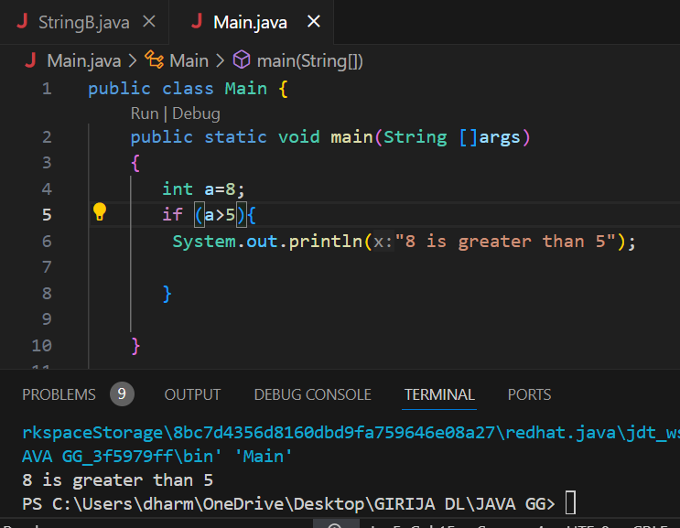

//IF ELSE

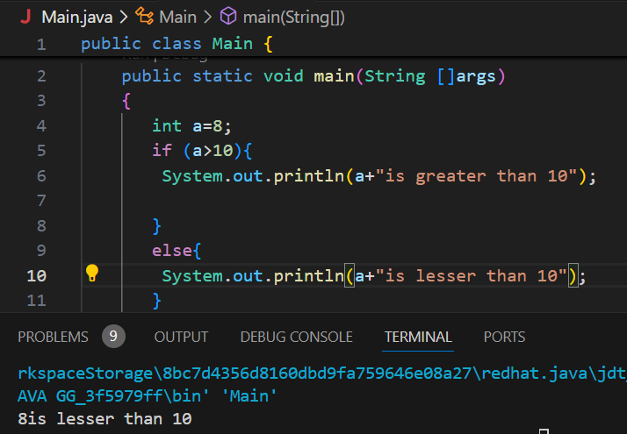

// IF ,ELSE IF,ELSE

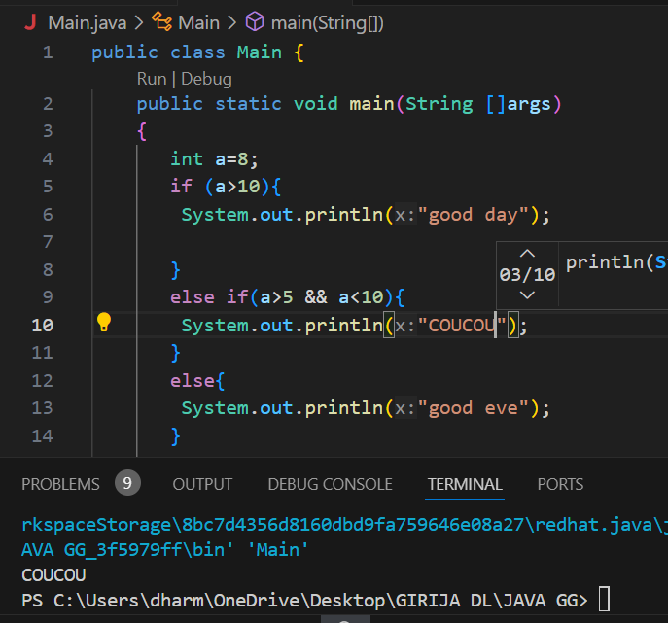

//SWITCH CASE

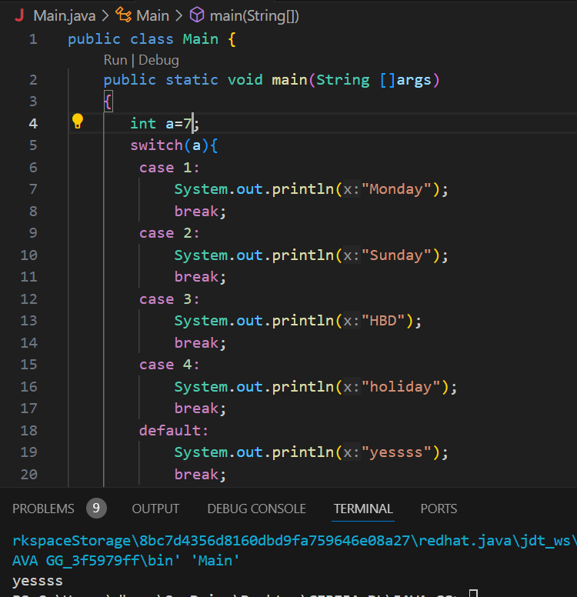

//WHILE LOOP

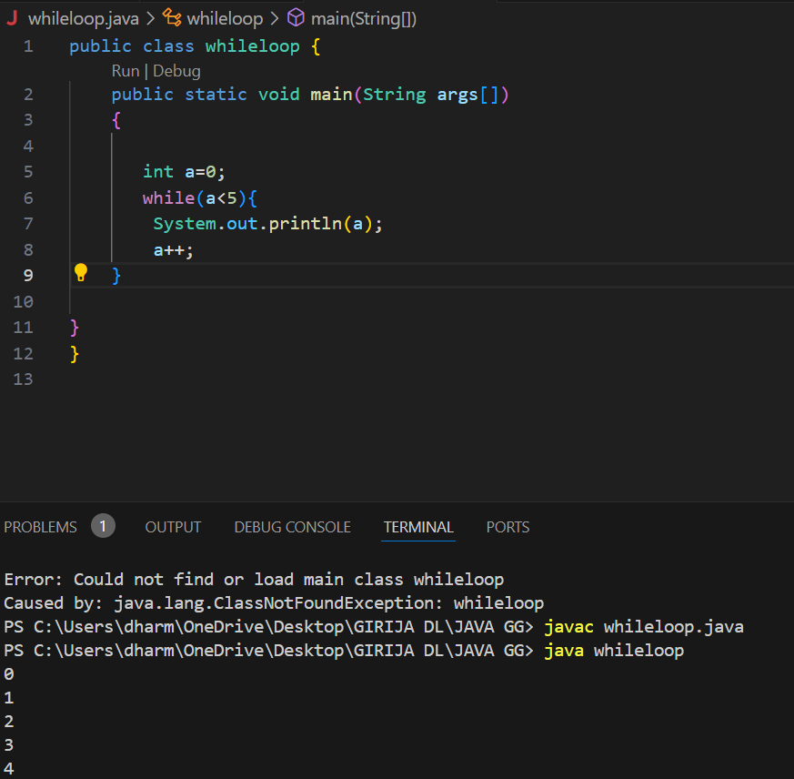

// do-while

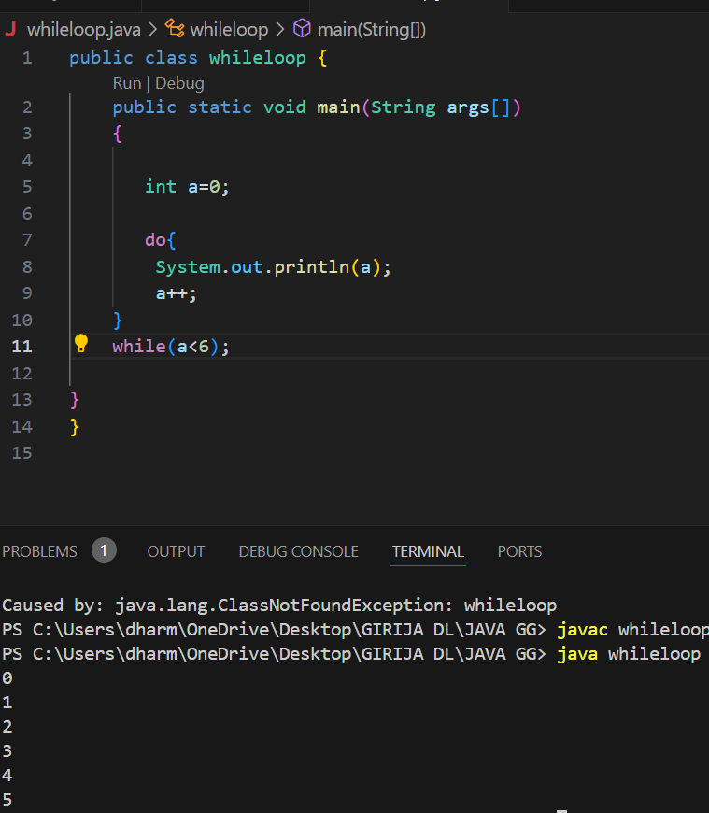

//for loop

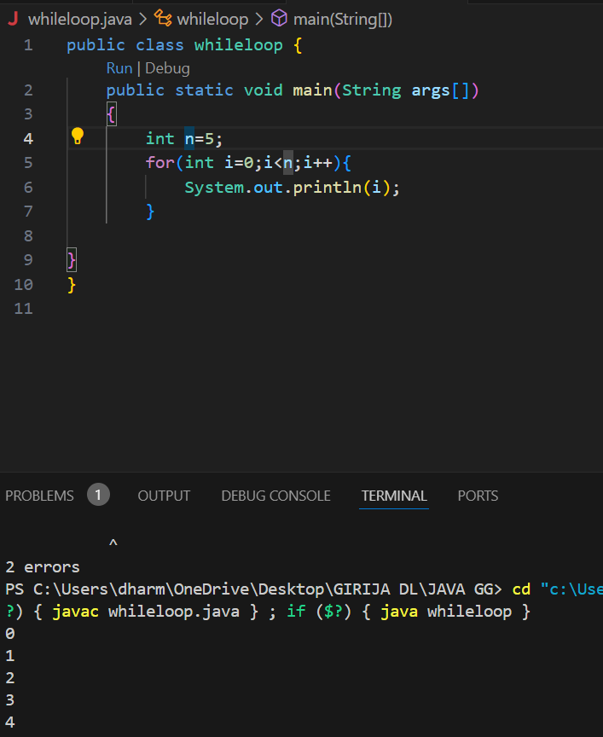

//FOR EACH

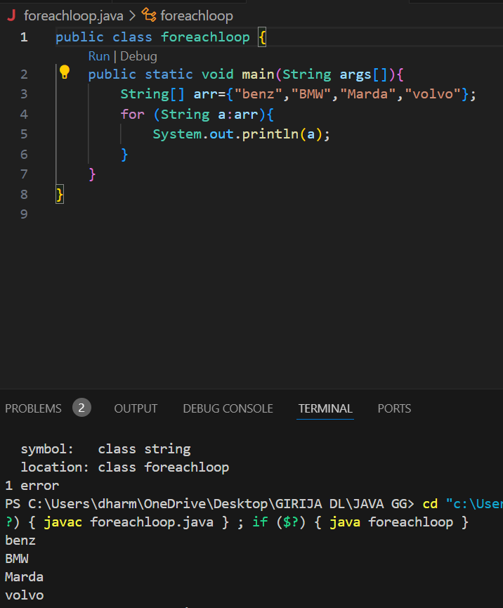

//BREAK IN LOOP

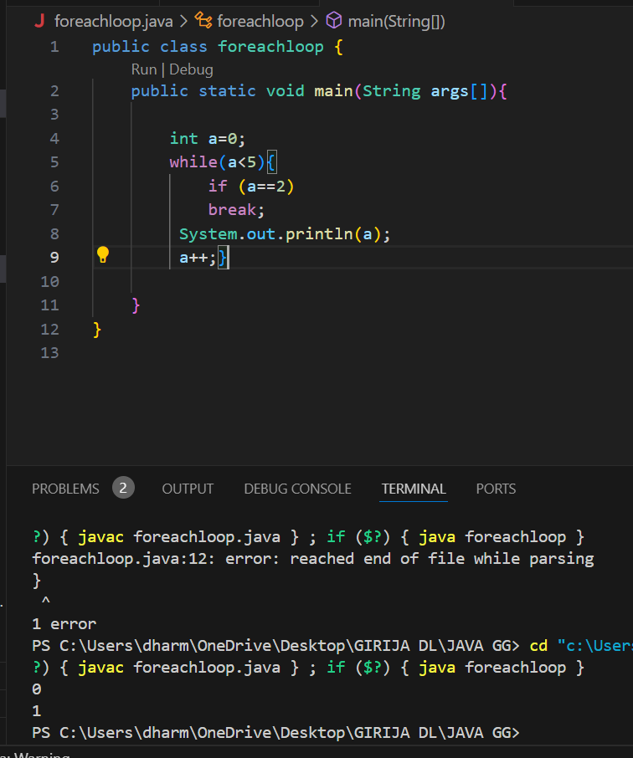

// User Input

